- Introduction to JDBC
Theory:
- What is JDBC(Java Database Connectivity)?
Ans :-
JDBC (Java Database Connectivity)
JDBC is a Java API that enables Java applications to interact with relational databases. It provides a standard interface for connecting to databases, executing SQL queries, and processing results. JDBC acts as a bridge between your Java code and the database, using drivers specific to each database vendor.
- Importance of JDBC in Java Programming
Ans :- JDBC provides a unified API that works across all major databases (MySQL, Oracle, PostgreSQL, SQL Server, etc.). You only need to change the driver and connection URL — not your code. JDBC is the base layer on which all major Java data frameworks are built.
- JDBC Architecture: Driver Manager, Driver, Connection, Statement, and Result Set
Ans :-
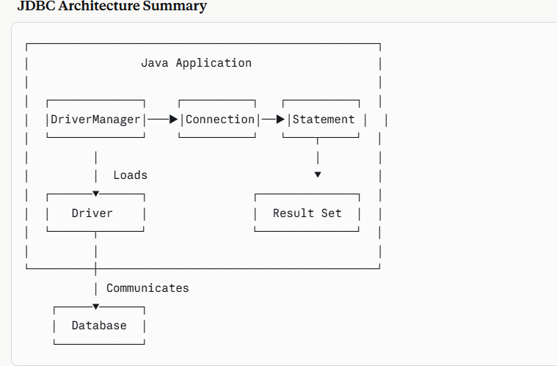

- JDBC Driver Types
• Theory:
- Overview of JDBC Driver Types:
  - Type1:JDBC-ODBCBridge Driver
  - Type2:Native-API Driver
  - Type3:NetworkProtocolDriver
  - Type4:ThinDriver
- Comparison and Usage of Each Driver Type
Ans:-

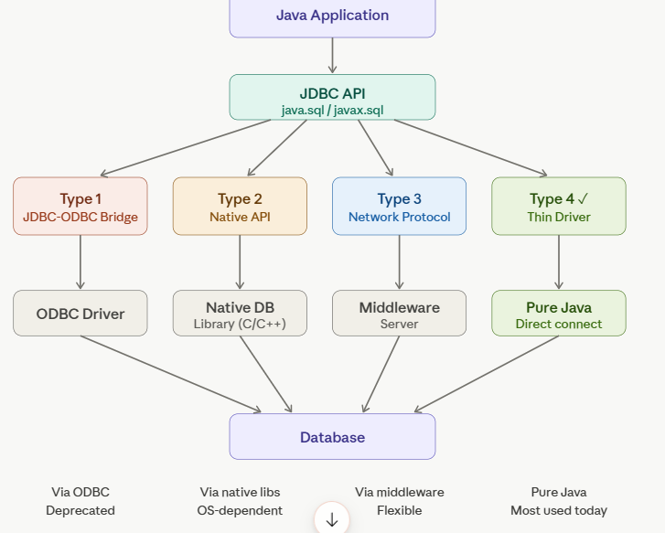

- Steps for Creating JDBC Connection.
Ans :-
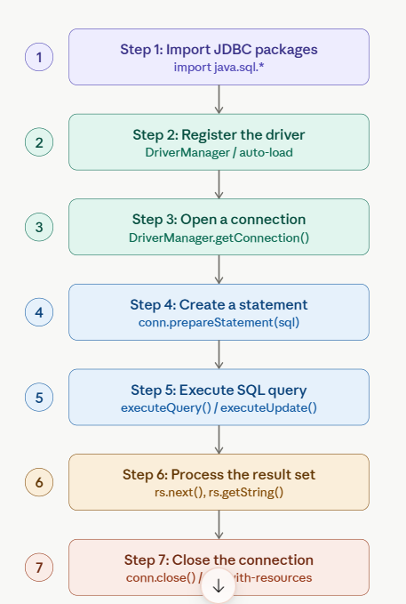

- Types of JDBC Statements

Ans:-
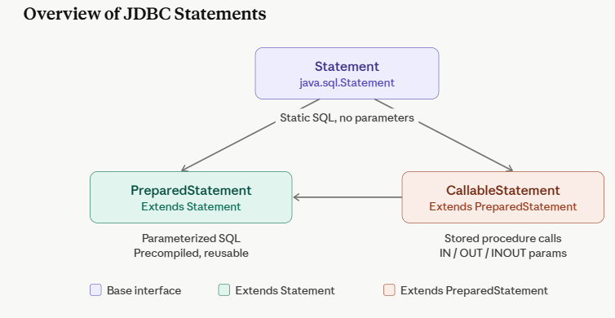

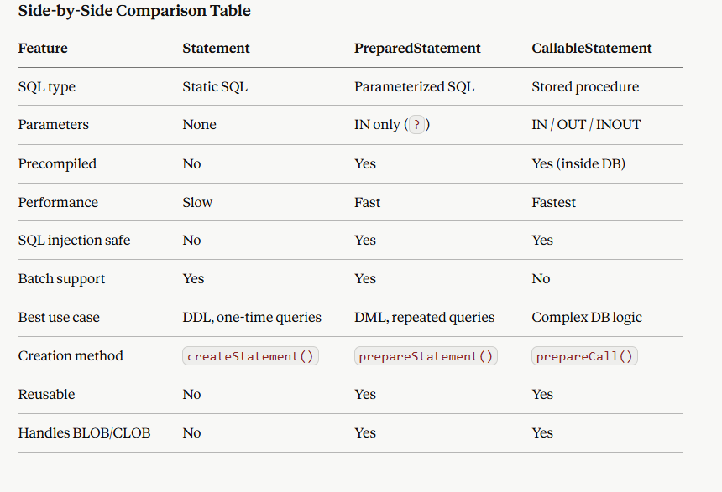

- Result Set Interface
Ans:- A Result Set is an object that holds the data returned by executing a SQL query (via executeQuery()). It represents a table of results with a cursor pointing to a row, initially positioned before the first row.
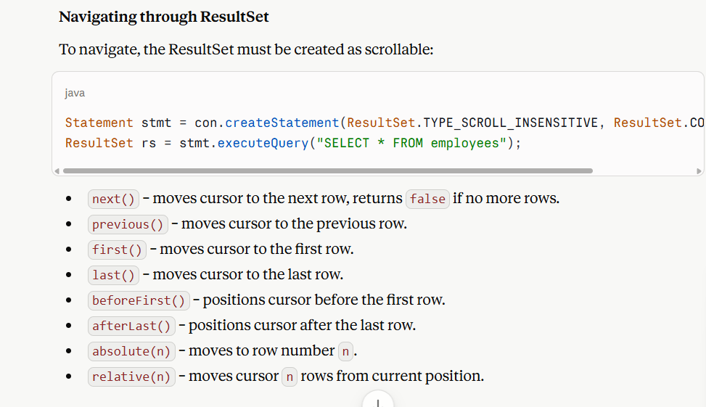

- Database Meta Data
Theory:
- What is Database Meta Data?
Ans :- Database Metadata is an interface that provides comprehensive information about the database itself — its structure, capabilities, and properties (not the data in tables, but data about the database).
- Importance of Database Metadata in JDBC
Ans:- Importance of Database MetaData in JDBC
- Database Independence/Portability – Applications can adapt to different databases (MySQL, Oracle, etc.) at runtime instead of hardcoding assumptions about features or syntax.
- Driver and Database Information – Allows retrieving driver name, version, database product name, and version, useful for debugging and compatibility checks.
- Schema Discovery – Enables dynamic discovery of tables, columns, primary keys, foreign keys, and indexes without prior knowledge of the database structure — essential for tools like database browsers, ORMs, and admin panels.
- Capability Checking – Lets the application check whether a database supports specific features (e.g., transactions, batch updates, stored procedures) before using them, avoiding runtime errors.

- Methods provided by Database Meta Data
Ans:-
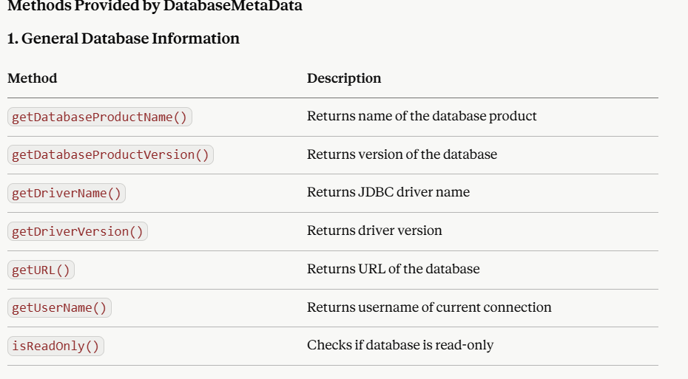

- Result Set Metadata
Theory:
- What is Result Set MetaData?
Ans:- ResultSetMetaData is an interface that provides information about the structure of a ResultSet — i.e., the number, types, and properties of columns in the result, rather than the actual data values.
- Importance of Result Set Metadata in analysing the structure of query results.
Ans:-
- Dynamic Column Discovery – Allows a program to determine the number of columns returned by a query without knowing the SQL statement in advance, essential when queries are user-defined or dynamic (e.g., SELECT *).
- Generic Data Display – Enables building generic tools (like database browsers, report generators, or admin panels) that can display results of any query in tabular format by looping through columns dynamically.
- Type-Safe Data Retrieval – Using getColumnType() or getColumnTypeName(), a program can call the correct getXXX() method (e.g., getInt, getString, getDate) based on actual column type, avoiding type mismatch errors.
- Column Naming and Labeling – getColumnName() and getColumnLabel() help display proper headers/labels in UI tables, reports, or exported files (CSV, Excel) even when aliases are used in the query.

- Methods in Result Set MetaData( getColumnCount, getColumnName, getColumnType)
